**Evidence for Analysis and Design Unit**

Name: Dan Kelsey

Cohort: E15

01/09/17

**AD 1 – Create a Use Case diagram**

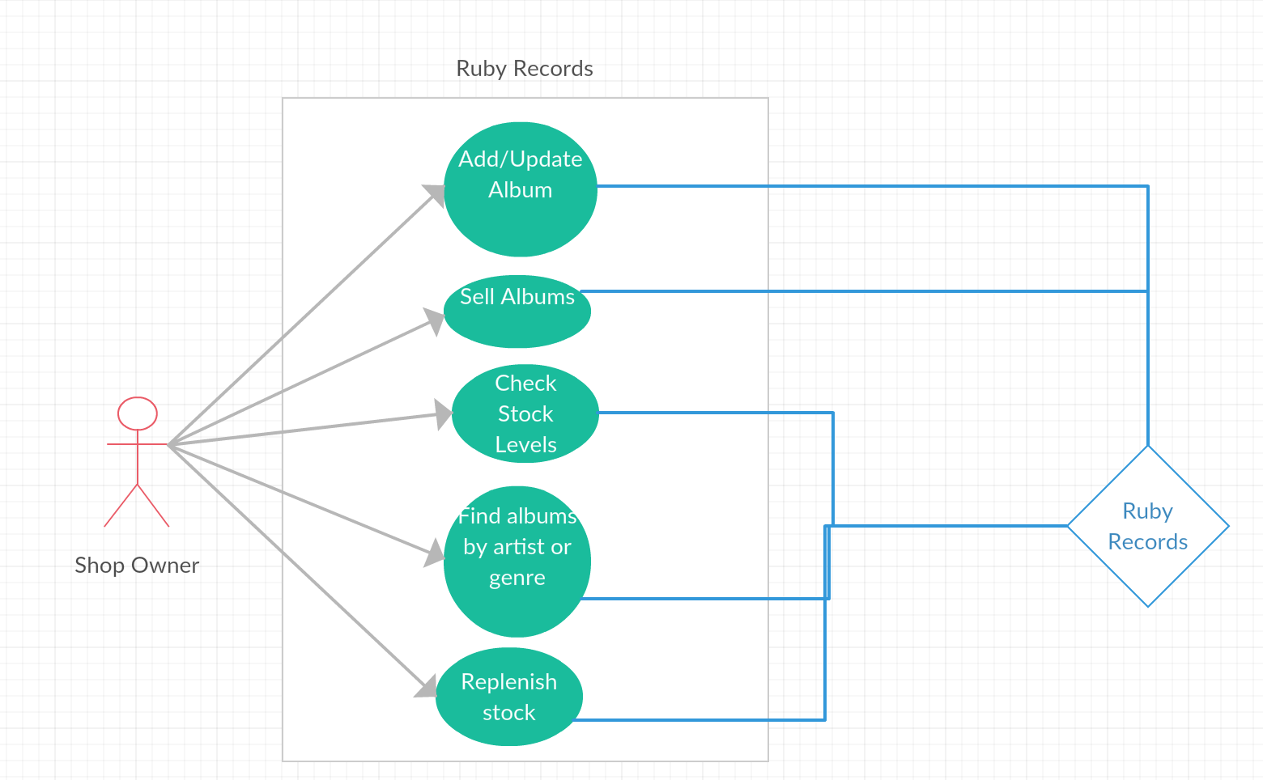

**AD 2 – Create a Class diagram using your Use Case diagram**

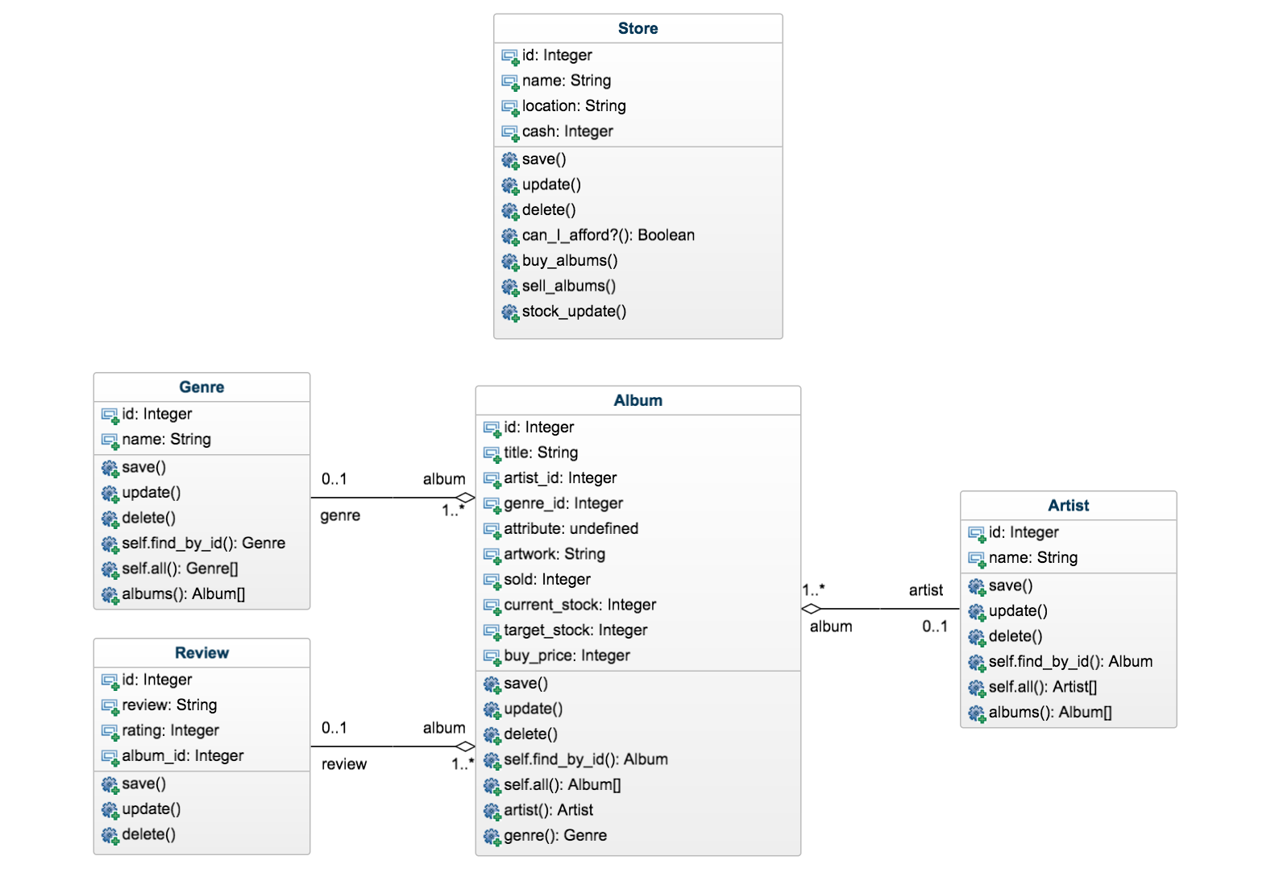

**AD 3 – Object Diagram**

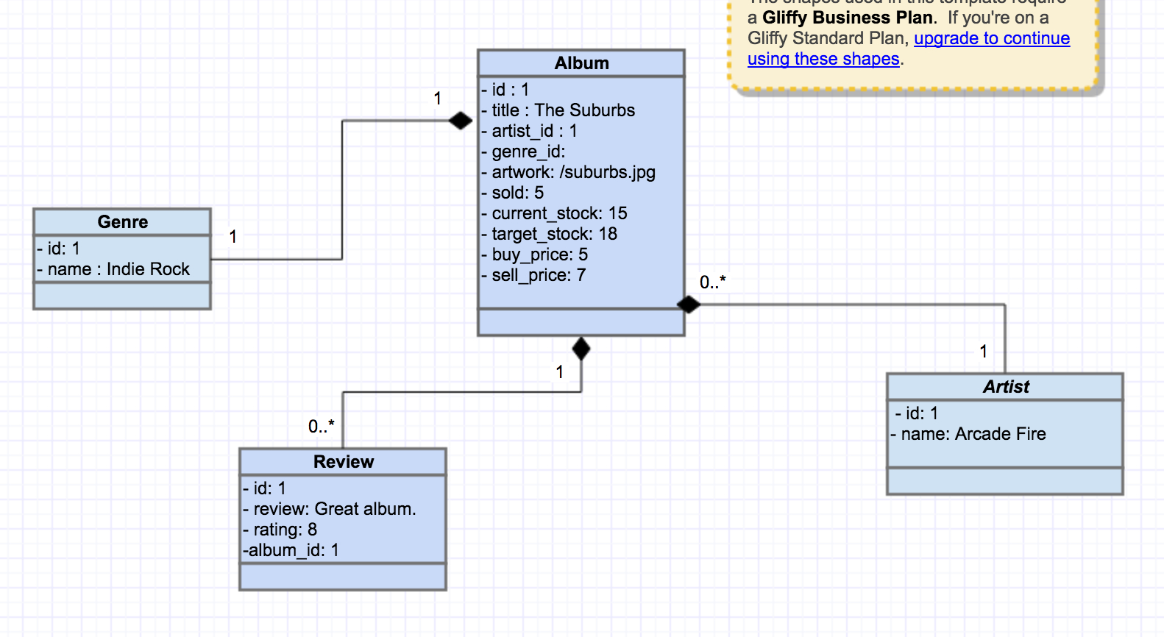

**AD 4 – Activity Diagram**

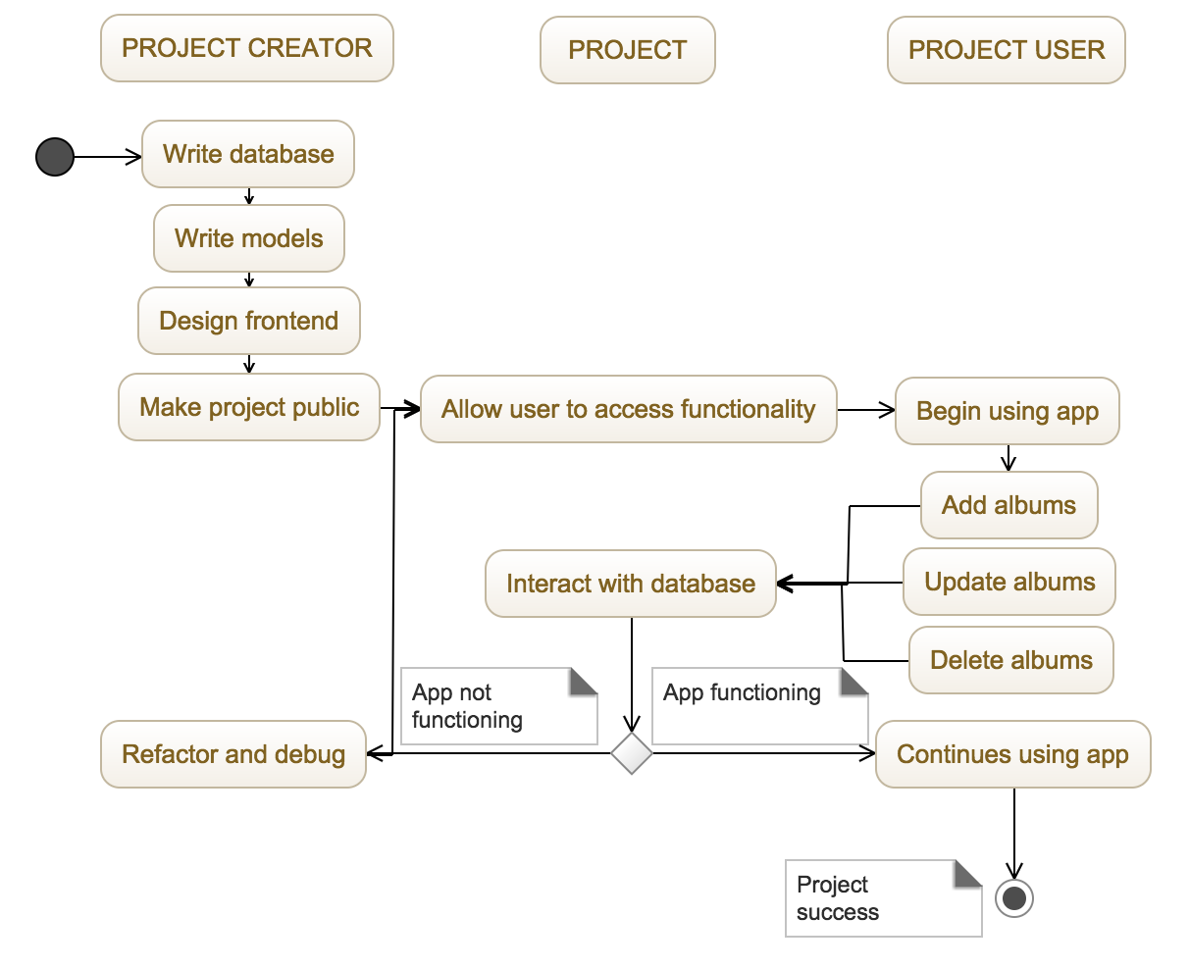

**AD 6 – Implementation Constraints**

|  |  |  |
| --- | --- | --- |
| **Constraint** | **Possible constraint** | **Details** |
| **Hardware and software platforms** | No responsive design – incompatible with mobile. | Include media queries in CSS next time – go Mobile First |
| **Performance requirements** | As only implemented locally, only accessible from my computer, not online | Not implemented online due to time constraints |
| **Persistent storage and transactions** | Performance would slow if high number of albums added. | Would increase memory/database capability with more time. |
| **Usability** | Website seems static and unresponsive | Implement JavaScript features with more time. |
| **Budgets** | No budget used. | Personal project for CodeClan |
| **Time** | Project was a week long – some features could not be included in this time. | Option to carry on working individually to implement more functionality. |